**PERIPHERAL NEUROPATHY RELIEF REPORT**



Finally! Help for Neuropathy Sufferers

Peripheral neuropathy is a frustrating, life-impairing condition. Many have been told they just have to medicate and live with it. Fortunately, with the recent advances in neurologic treatment technologies, relief is available for many neuropathy sufferers.

My name is Mark Shelley, DC, DACNB. In addition to being a doctor of chiropractic, I am a board certified Functional Neurologist. For over 30 years I’ve been helping patients find relief for chronic pain and nerve related conditions without drugs or surgery.

I continually hear how peripheral neuropathy sufferers experience symptoms like numbness, tingling, burning, coldness, or the sensation that their socks are rolled up under their feet. Because of those symptoms, many have problems standing, walking, or sleeping, let alone engaging in normal activities like hiking or golfing.



## Signs of Peripheral Neuropathy

* Difficulty walking
* Numbness
* Burning or freezing sensations
* Throbbing
* Prickling or tingling sensations
* Shooting/electric sensations
* Reduced balance

These symptoms have one thing in common: they rob neuropathy sufferers of their quality of life. What makes it worse is that most have been told there’s no way to find relief outside of taking drugs to just mask the pain. I want you to know that’s not always the case: and masking the pain with drugs does NOT prevent the progression of nerve damage. At Olympic Spine and Sports Therapy, we use a combination of up to eight different treatments to rehabilitate damaged nerves. Treatment includes therapies like non-invasive laser and balance therapy customized for each patient. All our treatments are non-surgical, drug and pain free. Best of all, for patients that qualify, they’re highly effective!

In this report, I will cover several aspects of neuropathy, including:

* The symptoms and causes of peripheral neuropathy
* Common medical treatment for this complicated condition
* And of course, we’ll go in depth into the comprehensive treatments we use to rehabilitate our patients’ damaged nerves to help them regain their quality of life.

If you, or someone you know is suffering from neuropathy, I hope you find this report helpful to better understand the condition, and your treatment options.

## What is Peripheral Neuropathy? C:\Users\Olympic.OLYMPIC\AppData\Local\Microsoft\Windows\INetCacheContent.Word\shutterstock_121961872.jpg

Neuropathy simply means that the nerves are not working properly. The National Institute of Health estimates 20 million people in the United States have some form of peripheral neuropathy. More than 100 types have been identified, each with its own symptoms and prognosis, but there are some tell-tale signs that nerve damage has occurred. While there are many different types and classifications of neuropathy, the actual symptoms can generally be grouped into two basic classifications: Negative and Positive Symptoms.

## Symptoms of Peripheral Neuropathy

Some patients describe what are classified as “negative” symptoms. These include sensations such as decreased sensitivity, numbness, tingling, or feeling like their hands or feet are dead or asleep. Balance can also become impaired. If the condition is allowed to progress, reduced sensation can become dangerous because of increased risk for falls and resultant injuries.

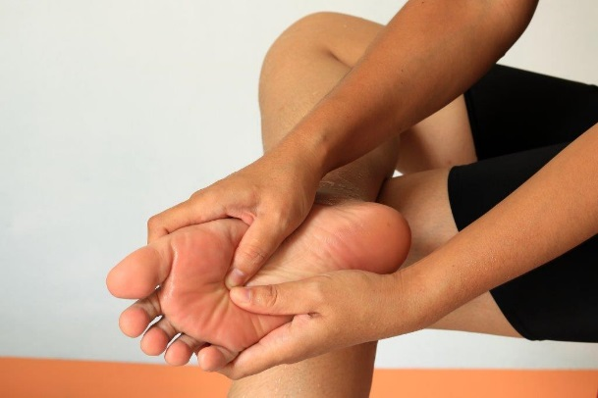Other patients experience what, strangely enough, are categorized as “positive” symptoms. Positive symptoms include sensations like aching pain, burning, electrical sensations, pressure or squeezing, throbbing, freezing, stabbing or feeling like their socks are balled up underneath their toes. Some patients suffer from both “negative” and “positive” symptoms simultaneously, which is just as unbearable as it sounds! Some will experience signs indicating impairment of their autonomic nervous system, such as discoloration and temperature changes in their hands or feet. They may have a red, swollen appearance, and feel hot to touch. Others take on a cyanotic blue or purple hue, and are cold due to lack of circulation.

Each patient will experience a different combination of these symptoms, and as the condition progresses, they can become more severe and have a growing impact on the patient’s quality of life and family. Standing and walking can become limited and laborious. Ultimately, independent mobility may be threatened. Some neuropathy sufferers are forced to rely on walking aids, progressing from a cane to a walker, eventually ending up in a wheelchair. It’s important to begin treating neuropathy as soon as possible to assure nerve damage does not progress to the point that rehabilitation is no longer possible.

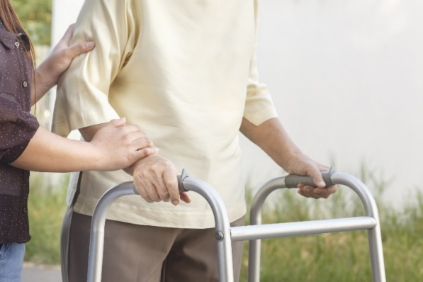Thankfully, due to advances in neuroscience and technological breakthroughs, many neuropathy sufferers can now slow or stop the progression of their condition, and experience relief of pain and restoration of sensation balance, strength, and mobility. Now we’re able to help many neuropathy patients regain their lost quality of life.

## Types and Causes of Peripheral Neuropathy

In general, peripheral neuropathies are classified by their location and the type of nerves involved. Examples include:

* Mononeuropathy: affecting a single nerve
* Mononeuritis multiplex: affecting multiple nerves asymmetrically
* Polyneuropathy: affecting multiple nerves symmetrically
* 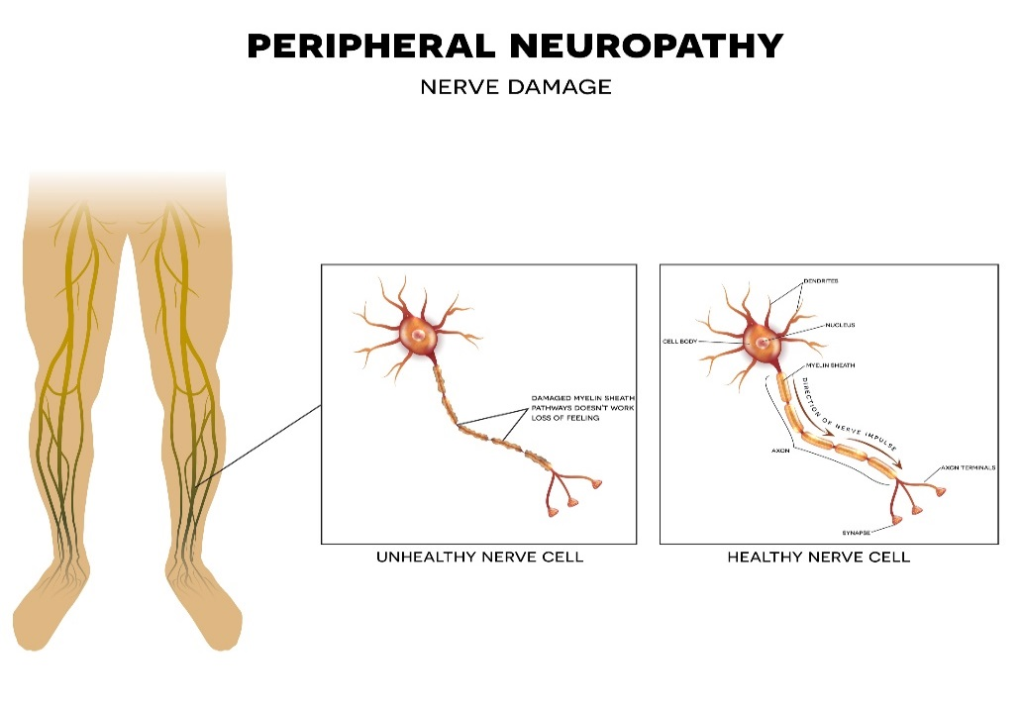Distal Symmetric Polyneuropathy: affecting multiple nerves symmetrically, starting in the feet and hands

The most common cause of distal symmetric polyneuropathy in western countries is Type 2 Diabetes. Many patients come to us suffering from what is classified as Diabetic Nerve Pain. Many causes of neuropathy are considered “idiopathic,” meaning the cause is unknown. This can be extremely frustrating for patients and doctors alike. Other causes of Peripheral Neuropathy include:

* 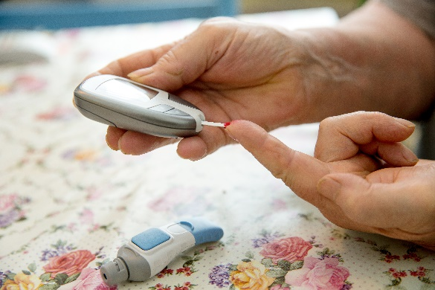Systemic disease
* Autoimmunity
* Vitamin/mineral deficiency or overdose
* Genetics
* Viruses & infections
* Excessive alcohol consumption
* Toxins
* Prescription drugs
* Chemotherapy
* Physical/Mechanical compression, i.e. sciatica

due to disc herniation

## Standard Treatment

Most neuropathy sufferers come to us because they haven’t been helped with standard medical treatment. Many have been told there’s nothing that can be done to treat their condition, and that they must learn to live with it. Some have been given prescriptions for medications that produce worse side effects than the neuropathy. Medications frequently prescribed for neuropathy include:

* Anti-Seizure Prescriptions
  + Neurontin
  + Gabapentin
* Anti-Convulsants
  + Lyrica
  + Pregambalin
* Serotonin Reuptake Inhibitors
  + Cymbalta
  + Duloxetine
* Opioids
  + Tramadol
  + Oxycodone

These medications come with a laundry list of potential side effects, including: dizziness, blurred vision, dry mouth, constipation, impaired cognitive abilities, and addiction.

There is no drug that can restore lost sensation or improve impaired balance that is due to peripheral neuropathy. Taking medication is not going to rehabilitate the nerves. As numbness and tingling progress, position-sense and stability deteriorate, with the inevitable consequence of an increased risk of a fall.

It’s no wonder neuropathy is so frustrating for patients and physicians. It’s the same reason patients who qualify for our non-surgical, FDA-cleared, drug and pain free treatments are so thankful they found us- because they’re effective!

## Who is a Candidate for Treatment?

The process we use to determine if a patient is a candidate for our treatment is simple. The first step is to schedule a consultation. We provide consultations and screening evaluation free of charge! During the consultation, the doctor will screen for signs of medical conditions that would rule out treatment. If medical management is necessary, we want to quickly get you to the correct provider. Then, a series of tests will be conducted to ascertain the extent of the nerve damage. The results of these tests will help determine if you are a candidate for treatment. Even with our comprehensive treatment approach, if the neuropathy has progressed too far, conservative treatment may no longer be an option. Next, the test results are assessed to determine how much improvement the patient is likely to receive. Each patient’s condition is unique to them, as is their treatment. The underlying cause, extent of nerve damage, and overall health of the patient all contribute to how well and how quickly someone will respond to our treatment. Providing realistic expectations for all our patients is a top priority.

## How Long Does It Take and How Much Does It Cost?

Next, patients are presented with a treatment plan that outlines the type of rehabilitation methods that are recommended to treat their neuropathy. They learn about the time requirements in the clinic and at home, as well as the cost involved.

**Treatment time and frequency**

The comprehensive treatments used in our clinic typically take from 45 to 90 minutes. The frequency of treatment sessions most often starts at two to three days per week, then reduces to one day per week as the patient improves. Again, this is variable, as the treatment for each patient is customized to their individual needs.

**Home care-effort and energy**

Participation in the treatment process is a necessity for long-term success dealing with peripheral neuropathy. In the initial stage of treatment, it is optimal for patients to perform their home care procedures two times per day. Each session typically takes between 15 and 20 minutes to complete.

**Treatment cost and insurance**

Although the primary treatment procedures we use like High Dose Class 4 Laser, Non-Surgical Decompression, and Infrared Therapy are FDA cleared, most insurance companies do not cover them. Insurance is designed to pay for drugs and surgery. Most of the patients that come to us to rehabilitate their nerves (not just mask their symptoms) are willing to incur personal expense to get effective treatment. I know that doesn’t answer the question, “How much does it cost?”. To give you meaningful answers regarding the cost of treatment, we need to know the nature of your condition, and how much treatment it will require. That is why we provide your consultation and screening evaluation free of charge. We want to determine whether we can help you, and let you know how much treatment you will likely need, before you incur any expenses. That’s the way we run our practice - we want to answer as many of your questions as possible up front.

## 

## An Explanation of Our Comprehensive Therapies

Neuropathy rehabilitation plans are customized to each patient’s treatment needs. Not all our therapies are appropriate or necessary for every patient. Treatment may include:

* High Does Laser Therapy
* Vibration Therapy
* Nutritional Supplementation
* Life Style Recommendations (like sleep, diet, exercise, stress management)
* Non-surgical Spinal Decompression
* Balance Therapy
* Infrared Therapy
* Manual Therapy: Joint mobilization/adjustment, Trigenics®, High Dose Laser Therapy

**Laser Therapy**

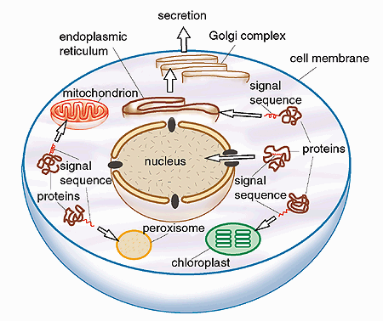Clinical studies and research using laser therapy have demonstrated reduced pain and inflammation, as well as stimulated nerve regeneration, muscle relaxation, and improved immune system response. There are many different types of lasers, depending on the specific wavelength, frequency, and power. lasers can be used to cut through steel, or to heal damaged tissue.

The Class IV Laser was FDA approved in 2001. This specific class of laser produces light in the visible and near infrared range, which is absorbed by mitochondria and the cell membranes. Our body can benefit from absorbing certain frequencies and wavelengths of light, much like plants benefit from sunlight and use it to grow. ATP is the “energy currency” of the cell, so higher levels lead to an increase in cellular health and an increased rate of repair.

**Vibration Therapy**

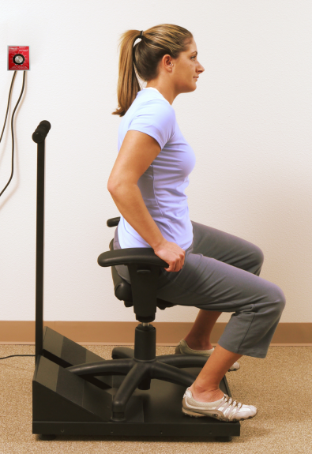Both whole body and region specific vibration therapy may be used in our treatment of neuropathy. Whole body vibration therapy has been used for the treatment of pain, rehabilitation, and to enhance athletic performance. Studies have demonstrated benefits such as:

1. Increased muscle strength and endurance. Muscle fibers can be activated up to 20-50 times per second. This allows muscle fibers to be exercised rigorously in a short period.
2. Increased blood and lymph circulation. Rapid contraction of the muscles produces a pumping action that increases circulation. This enhances the removal of cellular waste products, and improves the delivery of nutrients and fuel.
3. Increased activity of nerves. Vibrations activate receptors in the skin, which improves neuron function and viability.
4. Increased bone mineral density. Vibration has also been shown to increase the activity of osteoblast cells that make new bone, and to decrease the activity of osteoclast cells that reabsorb bone.

**Nutritional Supplementation**

Nerves need food and exercise to be healthy. Specific supplements have been found beneficial for nerve repair. Most neuropathy sufferers can benefit from some general supplement recommendations: however, prescription of supplements based on the cause of neuropathy, and specifics of the individual patient’s lab tests can be much more beneficial. Supplements we recommend are used to help heal damaged nerves by:

* Providing antioxidants to protect cells from free radical damage
* Promote nerve and blood vessel repair
* Reduce inflammation
* Stabilize blood sugar levels
* Support biotransformation-clearance of waste products
* Increase cellular energy production

**Lifestyle Recommendations**

For neuropathy sufferers, lifestyle factors can play a very important role in recovery. Where diet is concerned, for example if blood sugar level is too high or too low, nerves malfunction and can die. Concerning exercise, you have probably heard the saying “if you don’t use it you lose it.” Nerves are no exception to this rule. The single greatest source of activation of our nervous system comes from receptors in our muscles, called muscle spindles. Every time a muscle is stretched, the muscle spindle fires a signal activating nerves. This activation is essential for nerve health and longevity. The take-away from this is the importance of reviewing a neuropathy patient’s habits and lifestyle for significant contributing factors. The appropriate recommendations, support, or referral can greatly influence the individual patient’s outcome.

**Joint mobilization/adjustment**

**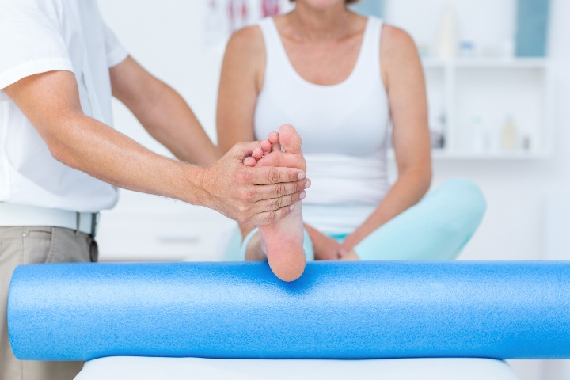**

As we just reviewed, every time a muscle is stretched, the muscle spindle fibers send a nerve impulse. If joints are restricted or fixated, muscle spindle fiber activity is reduced. Studies have shown that reduced input to our brain can cause deterioration of brain function. This can further compound the suffering, resulting in reduced sensation, numbness, or loss of dexterity, and strength in hands or feet. Joint mobilization and adjustments can restore lost mobility, improve muscle function, and increase the activation of nerves.

**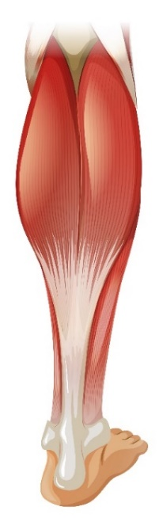Trigenics®**

As peripheral neuropathy progresses, most patients will experience weakness in the muscles of the affected areas. This is a contributing factor to loss of balance and stability that can lead to falls, and for some neuropathy patients, it can result in serious injuries. Trigenics® combines three procedures:

1. Resisted exercise
2. Nerve receptor activation
3. Neurologic breathing technique to retrain the way the nervous system controls the muscles around a joint

Correcting imbalances in muscle length and strength can normalize joint motion and restore stability. Often, the results are immediate. There is dramatic reduction in pain and increased mobility.

**Infrared Therapy**

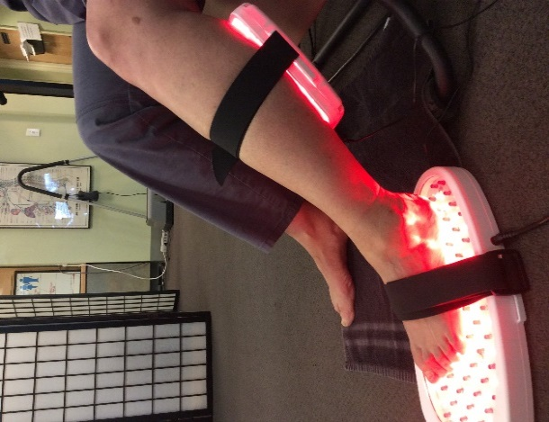“Fuel and activation” is the mantra in functional neurology. Fuel is glucose, and activation is exercise. Our comprehensive treatments are designed to feed and exercise the nerves. Studies have also shown that infrared light is beneficial for increasing circulation and improving nerve function. Infrared light therapy directly increases circulation to the nerves and other local tissues. This reduces inflammation, and increases delivery of nutrients, glucose, and oxygen. Typically, an infrared boot is used to cover the foot, and pads cover the back of the leg. Hands and arms can be treated in a similar fashion.

**Non-Surgical Spinal Decompression**

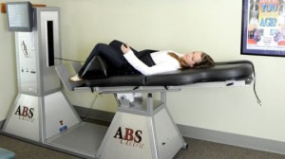Compression to nerves can be a cause of peripheral neuropathy. Many potential patients come to us with both distal symmetric polyneuropathy AND nerve compression. Clues to this combination of conditions are symptoms that start on one side only, or are noticeably more severe on one side than the other. More obvious clues are having a back or neck pain that accompanies symptoms of neuropathy in the hands or feet. Patients with nerve compression require decompression in addition to peripheral neuropathy treatment. When conservative measures have failed, the standard medical treatment for spinal nerve compression is decompressive surgery. Most medical experts agree that back surgery should be a last resort. According to Arnold Weil, MD, Clinical Assistant Professor of Rehabilitation medicine at Emory University School of Medicine, “probably less than 5% of all back pain requires surgery.” Instead of surgically removing disc material causing pressure on the nerves, non-surgical spinal decompression uses a sophisticated machine that gently stretches the spine, creating negative pressure inside the disc. This creates a vacuum that draws bulging disc material back into place. Non-surgical spinal decompression is another valuable treatment available in our FDA-cleared, drug and pain free treatment approach.

**Balance Therapy**

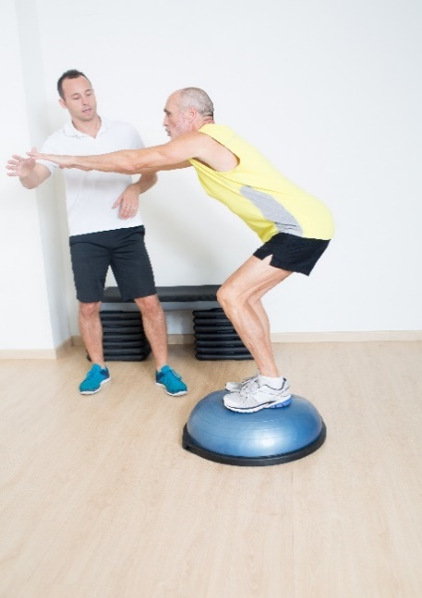Unsteadiness, staggering when walking, a dizzy/lightheaded feeling, tripping, and falling are all signs of balance problems. According to the Center for Disease Control and Prevention, roughly MORE THAN ONE THIRD OF ADULTS, AGE 65 YEARS AND OLDER, FALL EACH YEAR. Unfortunately, the fear of losing their ability to live independently can prompt seniors to withhold information about impaired balance from family and physicians. Preserving independence in activities of daily living and mobility is a chief concern for our neuropathy patients. Balance therapies tailored to each patient are part of our comprehensive treatment plan for every peripheral neuropathy patient. Many of our patients say that the greatest benefit they received from treatment is regained confidence in their ability to walk, and the ability to return to a vibrant and active lifestyle.

## Home Care Procedures

In addition to the in-office treatments for peripheral neuropathy, each patient is trained how to perform home therapies. These home treatments become the foundation for maintenance therapy. Patients are assigned simple at-home exercises such as:

* Thermal contrast
* Mechanical nerve stimulation
* Stretches/exercises
* Sensory motor coordination
* Balance exercises

Thank you for taking time to learn about peripheral neuropathy and your treatment options. There are three things I really want you to take away from this report.

1. Don’t put off getting evaluated. We can help most neuropathy sufferers if they start treatment before it has progressed too far.
2. Medications only mask your symptoms. They can’t prevent progression of your condition or improve your balance.
3. We have helped thousands of patients with neuropathy. Don’t accept that you have to live with it, without being evaluated first. Our comprehensive treatments can help rehabilitate damaged nerves, reduce symptoms, improve balance, and help neuropathy sufferers regain lost quality of life.

If you’re suffering from any of the symptoms of neuropathy: tingling/numbness in your hands or feet, stabbing, shooting, burning pain or impaired balance, call the number below and schedule a free consultation. We will evaluate your condition and let you know whether or not you are a candidate for our non-surgical, drug, and pain-free therapies. Your consultation is free of charge, and could completely change the quality of your life. I look forward to seeing you at our office. Thanks again for taking time to learn about your treatment options.



6603 220th ST SW #102 | Mountlake Terrace, WA 98043 | 425-774-2411 | [help@olympicspine.com](mailto:help@olympicspine.com)

**Patient Testimonials**

**“I can walk without discomfort now, I even went dancing!”**

Jeanne’s Story

**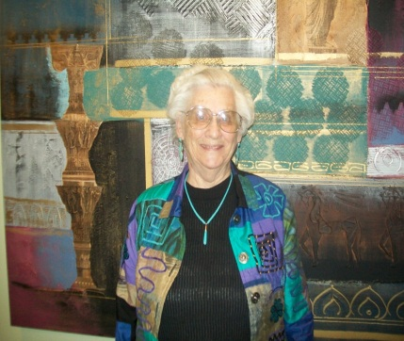**When I started, I had numbness in my big toes and tingling in both sides of my legs. It bothered me most when I walked, it was really irritating! A friend, John recommended I come to Olympic Spine and Sports Therapy. Right from the beginning it just started to gradually feel better. The numbness and tingling is a lot less intense now. There is no numbness in my big toes. I can walk without discomfort now and I even went dancing! The staff is helpful and caring, I even brought them goodies at Christmas! ***—* Jeanne B, Seattle**

**“The symptoms were so bad, it was like walking on broken glass”**

Dave’s Story

For the past 10 years, I had pain in my toes that progressed to my feet. I saw my general M.D., a neurologist and an orthopedist. I was diagnosed with idiopathic peripheral neuropathy and they said there was no treatment or cure. All I was offered was medication, and that didn't always work. The symptoms were so bad it was like walking on broken glass. Even walking on the carpet or the lawn was too painful. All I could do to relieve the pain was get off my feet. My quality-of-life suffered because there were so many things I couldn't do. After four or five weeks of treatment at Olympic Spine and Sports Therapy, I started feeling better and from then on, I really noticed a big improvement. Now I can walk on the grass and carpet and stay on my feet longer than I could for years. I've taken on home-improvement projects I never would've attempted before treatment. I'm excited to go on a four-day golfing trip, that would never have been possible before my treatment. Now, I go through my day without even thinking about my feet! -**Dave K, Covington**

**10 Years of Foot Pain & Numbness Improved after Drugs & Injections Fail**

Gregg’s Story

For over 10 years I've experienced pain and numbness in my feet. Over time, it got progressively worse. I was waking up 5-6 times a night and was only able to get a few hours of sleep. My orthopedist prescribed gabapentin, and my neurologist told me nothing else could be done to treat my condition. Injections temporary relieved the pain, but it always returned and the numbness progressed. After a couple of weeks of treatment at Olympic Spine and Sports Therapy, I noticed I wasn't waking up as frequently during the night and I began to feel more rested. Even my balance and confidence when I’m on my feet improved! My symptoms have become manageable and day-to-day activities easier. I can even sleep through the night and not be awakened by the pain! -**Gregg K, Bothell**

**Peer-Reviewed Clinical Studies**

These following studies have been published in medical journals that have a rigorous peer-review process. They are listed chronologically.

1. Kochman AB, Carnegie DE, Burke TJ. **Symptomatic Reversal of Peripheral Neuropathy in Patients with Diabetes.** *Journal of the American Podiatric Medical Association.* 2002;92:125-130.
2. Pendergast JJ, Miranda G, Sanchez M. **Improvement of Sensory Impairment in Patients with Peripheral Neuropathy.** *Endocrine Practice.* 2004;10:24-30.
3. Leonard DR, Farooqi MH, Myers S. **Restoration of Sensation, Reduced Pain, and Improved Balance in Subjects with Diabetic Peripheral Neuropathy; A Randomized, Double Blind, Placebo Controlled Study.** *Diabetes Care.* 2004;27:168-172.
4. Kochman AB. **Monochromatic Infrared Photo Energy and Physical Therapy for Peripheral Neuropathy: Influence on Sensation, Balance and Falls.** *Journal of Geriatric Physical Therapy.* 2004;27:16-19
5. DeLellis S, Carnegie DE, Burke TJ. **Improved Sensitivity in Patients with Peripheral Neuropathy: Effects of Monochromatic Infrared Photo Energy.** *Journal of American Podiatric Medical Association.* 2005; 95(2):143-147.
6. Harkless L, DeLellis S, Burke TJ. **Improved Foot Sensitivity and Pain Reduction in Patients with Peripheral Neuropathy after Treatment with Monochromatic Infrared Photo Energy-MIRE ™.** *Journal of Diabetes and Its Complications.* 2006;20(2):81-87.
7. Volkert W, Hasaan M, et al. **Effectiveness of Monochromatic Infrared Photo Energy and Physical Therapy for Peripheral Neuropathy: Changes in Sensation, Pain and Balance – A Multi-Center Chart Review.** *Physical and Occupational Therapy in Geriatrics.* 2006;24(2):7-18.
8. Powell MW, Carnagie DH, Burke TJ. **Reversal of Diabetic Peripheral Neuropathy with Photo Therapy (MIRE ™) Decreases Falls and the Feat of Falling, and Improves Activities of Daily Living in Seniors.** *Age and Ageing.* 2006;35(1):11-16.
9. Ammar, T. **Monochromatic Infrared Photo Energy in Diabetic Peripheral Neuropathy.** *International Scholarly Research Network (*ISRN) *Rehabilitation.* 2012; Article ID 484307.

O:\Peripheral Neuropathy\Peripheral neuropathy relief report 2-16-17.docx